Professional Development Agenda: Introduction to Science Practices
Approximate Length of PD: 1.5 hours

Overview
This document illustrates how a professional development session can be designed using the ILSP resources. The goal of such sessions is to support teachers to develop stronger understandings of the science practices and to integrate those science practices into their classroom instruction. This is a generic agenda that can be adapted to focus on one specific science practice or on groups of practices.

Goals
- Teachers will be introduced to one target science practice or to a groups of practices and discuss the definition(s) and the different levels along the Science Practices Continuum.
- Teachers will critique two case studies illustrating the target science practice(s) and discuss the instructional strengths and challenges.
- Teachers will identify instructional strategies to support the target science practice(s) for both the case studies and their own future instruction.

Professional Development Sequence
Purple = suggested core activities
Blue = suggested additional activities for more time or more in-depth study

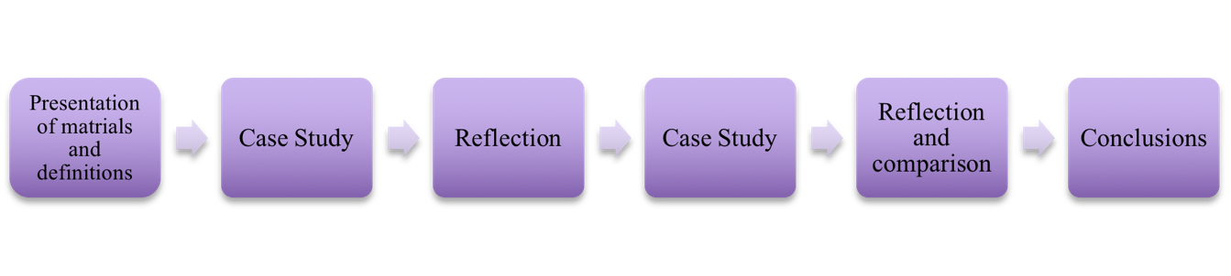
Critique a lesson plan
Revise a lesson plan
Design a lesson
Experience a typical lesson

General Agenda – Introduction to Science Practices

Activity | Description | Time
Overview and Introductions | - Overview of the workshop  - Have everyone introduce themselves  - Name, familiarity with NGSS science practices | 10 min
Presentation of Materials and Definitions | - Introduce new vision of science as a set of practices  - Introduce the focal science practice(s) for that day (e.g. models)  - Share NGSS Practices definitions from ILSP http://www.sciencepracticesleadership.com/definitions.html  - Share continuum and discuss its use http://www.sciencepracticesleadership.com/continuum.html | 20 min
Activity #1: Case Study | Video/Vignette that is high on the continuum for the focal practice(s)  - Select and watch the video or read the vignette individually or in pairs for the target science practice - http://www.sciencepracticesleadership.com/case-studies.html  - Using the definitions, identify which of the 8 practices are currently in the lesson as it was taught.  - Using the continuum, identify the level of each of the practices that was present in the instruction.  Handout: chart of the 8 practices with space to record whether the practice was present, evidence for its presence, and continuum level. | 10 min
Reflection | Discussion (whole group or in pairs/small group)  - What practices did you see in the lesson the way it was taught? What was your evidence?  - Where did you put the practices on the continuum? Why?  - Were there practices that you felt were missing? How would you incorporate them into this lesson?  - What strategies would you suggest to this teacher to improve the instruction of the science practices?  Handouts: ILSP instructional strategies for focal practices  - Discuss which instructional strategies might have value for this lesson and how they might be scaffolded for students. | 15 min
Activity #2: Case Study | Video/Vignette that is low on the continuum for the focal practice(s)  - Select and watch the video or read the vignette individually or in pairs for the target science practice - http://www.sciencepracticesleadership.com/case-studies.html  - Using the definitions, identify which of the 8 practices are currently in the lesson as it was taught.  - Using the continuum, identify the level of each of the practices that was present in the instruction.  Handout: chart of the 8 practices with space to record whether the practice was present, evidence for its presence, and continuum level. | 10 min
Reflection and Comparison | Discussion (whole group or in pairs/small group)  - What practices did you see in the lesson the way it was taught? What was your evidence?  - Where did you put the practices on the continuum? Why?  - How were these videos/vignettes similar?  - How were they different?  - Which do you think is more similar to the ways you currently teach? Why?  - What supports would help you incorporate more of a focus on the science practices into your instruction? | 15 min
Conclusions | - Questions?  - Major takeaways  - Plans for classroom instruction  - Follow-up and sharing with colleagues | 10 min

